**3B**



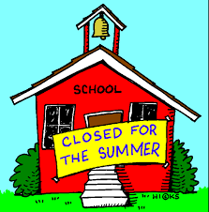 

**THIS WEEK… FROM THE TEACHER’S**

**DESK...**

* In **Math** students played math games that reinforced the concepts that were taught this year.
* We continued our **handwriting** program by reviewing the undercurve, downcurve, overcurve, and slant strokes, as well as all previously learned lowercase and capital cursive letters.
* In **Writing** students wrote a letter to author, Patricia Polacco.
* We continued our **Phonics** program by reviewing and practicing previously learned concepts.
* During the **Daily 5** students were able to independently practice all areas as we concluded our author study on Patricia Polacco.



This will be the last Newsbook of the year. As such, please keep it at home as a third grade keepsake. I hope that you enjoyed reading your child’s letters this year as much as I did.



**OTHER REMINDERS…**

Please don’t forget to read and practice your math facts over vacation.

Here is a message from Jenny Deane, Westborough’s K-6 Math Curriculum Specialist:

Summer is the perfect time for students of all ages to relax, but it’s also a time when summer learning loss can occur. This learning loss is called the “summer slide,” and happens when children do not engage in educational activities during the summer months.  Luckily, there’s a lot you can do—and it doesn’t have to be a drag, either. Summers are for fun, and that’s why we have some fun solutions for you and your child to work on together.  **Click**[**here**](https://sites.google.com/a/westboroughk12.org/k-through-6-math-curriculum/summer-math-1)**to access a variety of fun summer math activities!**

Thanks!

 

1.  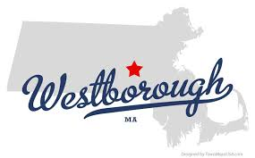ry your best!heck your work!



**OTHER REMINDERS…**

* Please remember to **respond** on the lined paper  provided to you in your child’s Newsbook. Your child begins each Monday morning by reading your messages.
* Please also remember to **sign** your child’s spelling test booklet each Friday and make sure that it is **returned** to school each Monday.

The April book order has been placed. Order forms for the final book order of the year will be sent home after April vacation.



**HAVE A WONDERFUL SUMMER VACATION!**



**I KNOW THAT YOU WILL ALL DO A GREAT JOB AT MILL POND!**

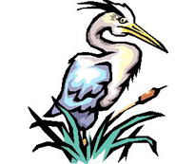

**DON’T FORGET TO COME BACK AND VISIT, ONCE A BLUE JAY, ALWAYS A BLUE JAY!**

