**3B**



 

**THIS WEEK...**

**FROM THE TEACHER’S**

* In **Math,** students stayed in their homeroom to complete a short data unit. **Please remember to have your child continue to practice his or her multiplication and division facts nightly.**
* We continued our **handwriting** program by practicing the undercurve, downcurve, overcurve and slant strokes, as well as all previously learned lowercase cursive letters. Capital letters **S** and **G** were also introduced.
* In **Writing,** students worked on researching and writing biography reports.
* We continued our **Phonics** program by learning and practicing how to make words that end in ‘y’ plural.
* During the **Daily 5**, students were able to independently practice all areas. We also continued a mini unit on Biographies. **Please remind your child to “Read to Self” for at least fifteen minutes a night and respond to our class blog by the end of the month.**
* We also concluded our study of **Force and Motion** by investigating the patterns of motion of carts and taking the end of unit assessment.

**DESK...**

**Mrs. Stohr’s Test Taking Tips:** Mrs. Stohr’s Test Taking Tips:

* Get a good night’s rest
* Eat a filling, healthy breakfast
* Relax
* Try your best

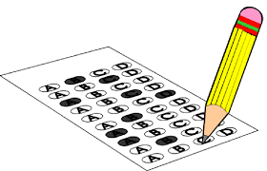

**OTHER REMINDERS…**

* Please remember to **respond** on the lined paper  provided to you in your child’s Newsbook. Your child begins each Monday morning by reading your messages.
* Also, please remember to **sign** your child’s spelling test booklet each Friday and have your child **return** it to school each Monday.
* The April book order has been placed. Be on the lookout for the new order form to be sent home with your child in early May.

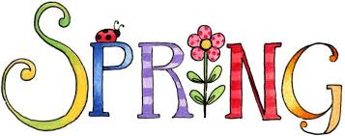

**NEXT WEEK…**

* In **Math,** students will travel to their flexible math classes to begin the Geometry unit.
* We will continue our handwriting program by practicing the undercurve, downcurve, overcurve, and slant strokes, as well as all previously learned lowercase and capital letters. Due to MCAS testing, no new capital letters will be introduced.
* In **Writing,** students will complete the final drafts of their biography reports.
* We will continue our **Phonics** program by reviewing and practicing previously learned concepts.Due to MCAS testing, no new concept will be introduced and no test will be given.
* In lieu of the **Daily 5**, students will be taking the ELA MCAS.
* We will begin our study of **The American Revolution** by identifying the causes that led to the war. Student will also participate in our own “Tax Day.” Be sure to ask your child abut their experience having to “pay” for classroom essentials!