**3B**



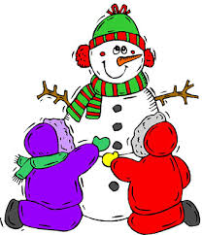

**THIS WEEK... FROM THE TEACHER’S**

* In **Math** students continued Unit 3, Multiplication and Division with Multiples of 10, in their flexible math classes. **Please remember to have your child continue to practice his or her multiplication and division facts nightly.**
* We continued our **handwriting** program by reviewing the undercurve, downcurve, overcurve, and slant strokes, as well as all previously learned lowercase and capital cursive letters.
* In **Writing** students worked on an opinion piece about snow days.
* We continued our **Phonics** program by learning about and practicing words that contain hard and soft c and g sounds.
* During the **Daily 5** students were able to independently practice all areas as we continued our nonfiction unit of study. Be sure to look at your child’s Daily 5 record sheet to see what choices they made this week. **Also, please remind your child to “Read to Self” for at least fifteen minutes a night AND comment in the January book log blog. It will close at the end of the month.**
* We began our study of **Weather** by investigating various tools and how they are used to measure weather.

**DESK...**

* **SAVE THE DATE:** The Spring MCAS dates have been set:
  + ELA – April 13-15
  + Math – May 12-14
* With winter here, please make sure that your child comes to school in the proper outdoor gear. Remember that to play in the snow outside, your child will need to wear snow pants, boots, gloves, and a hat. Also, please be sure to label all gear with your child’s name so that they are not lost or confused with a classmates’.

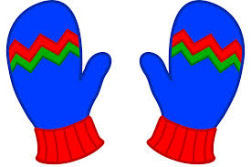

**OTHER REMINDERS…**

* Please remember to **sign** your child’s spelling test booklet each Friday and make sure that it is **returned** to school each Monday.
* The January book order has been sent home. If you wish to make a purchase, please send your child’s order form and payment back to school by Friday, January 24th.



**NEXT WEEK...**

* In **Math** students will continue Unit 3, Multiplication and Division with Multiplies of 10, in their flexible math classes.
* We will continue our **handwriting** program by reviewing the undercure, downcurve, overcurve and slant strokes, as well as all of the previously learned lowercase cursive letters. Students will also learn and practice capital cursive letters **E** and **N**.
* In **Writing** students will work on writing a biography report.
* We will continue our **Phonics** program by learning about and practicing words that contain double consonants.
* During the **Daily 5**, students will continue to work toward increasing their stamina and achieving greater independence as they enjoy all 5 areas. They will also enjoy reading about and researching a person of their choice as part of our mini-unit study on **Biographies/Narrative Nonfiction**.
* We will continue our study of **Weather** by learning more about the main components of a weather forecast and how meteorologists make their predictions.