**3B**



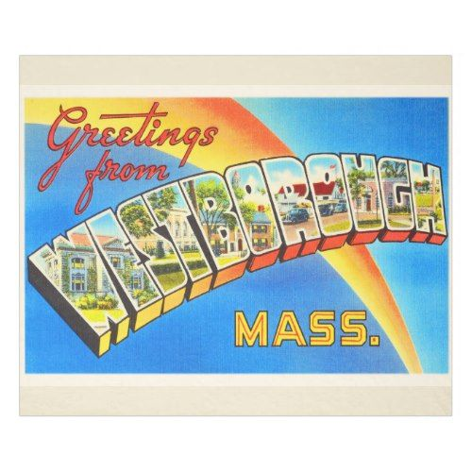

**THIS WEEK… FROM THE TEACHER’S DESK...**

* In **Math,** students traveled to their flexible math classes to continue our final unit, Geometry. **Please remember to have your child continue to practice his or her multiplication and division facts nightly.**
* We continued our **handwriting** program by practicing the undercurve, downcurve, overcurve and slant strokes, as well as all previously learned lowercase and capital cursive letters. Now that students have learned all the letters, they may write their daily work in cursive, if they choose.
* We continued our **Phonics** program by learning about and practicing words that contain tricky vowel combinations (-ie, -ei, and -eigh).
* In **Writing,** students crafted personal narratives about their first MCAS experiences.
* During the **Daily 5**, students were able to independently practice all areas. Be sure to look at your child’s record sheet to see what choices they made this week. **Please also remind your child to “Read to Self” for at least fifteen minutes a night and respond to our class blog by the end of the month.**
* We concluded our study of **Westborough History** by preparing for and taking the end of unit assessment.



Thank you to the parents that volunteered to chaperone our walking tour of Westborough, we’re sure to have a great time!

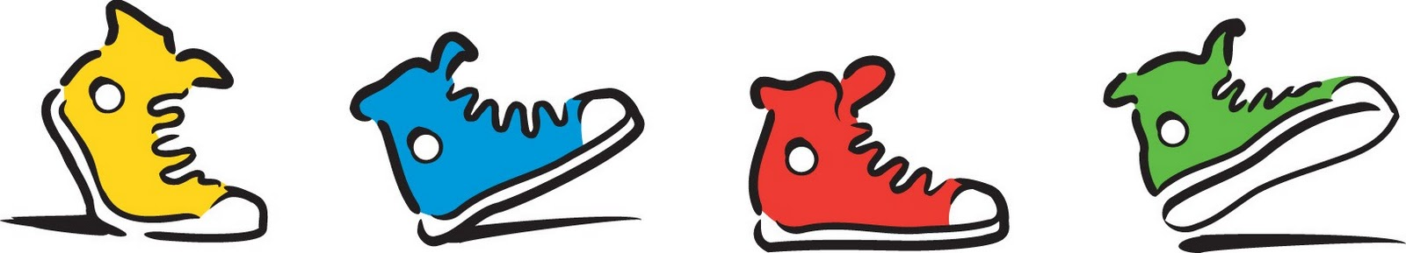

**Mark your calendars:**

* **6/13:** Third grade End of Year Celebration, **6:30PM**
* **6/17:** Field Day
* **6/20:** LAST DAY OF SCHOOL!



**OTHER REMINDERS…**

* Please remember to **respond** on the lined paper  provided to you in your child’s Newsbook. Your child begins each Monday morning by reading your messages.
* Also, please remember to **sign** your child’s spelling test booklet each Friday and have your child **return** it to school each Monday.

The May book order has been placed. Any book ordered should arrive by mid June.

1. ry your best!heck your work!



**OTHER REMINDERS…**

* Please remember to **respond** on the lined paper  provided to you in your child’s Newsbook. Your child begins each Monday morning by reading your messages.
* Please also remember to **sign** your child’s spelling test booklet each Friday and make sure that it is **returned** to school each Monday.

The April book order has been placed. Order forms for the final book order of the year will be sent home after April vacation.



**NEXT WEEK...**

* In **Math,** students will travel to their flexible math classes to conclude their study of Geometry.
* We will continue our handwriting program by practicing the undercurve, downcurve, overcurve, and slant strokes, as well as all previously learned lowercase and capital letters. Now that students have learned all letters, they may write their daily work in cursive, if they choose.
* In **Writing,** students will write several reflections about their experiences on our various Westborough field trips.
* In **Phonics** students will review and practice previously learned skills and concepts. Due to the shortened week and number of scheduled special events, no test will be given.
* During the **Daily 5**, students will continue to work toward increasing their stamina and achieving greater independence as they enjoy all 5 areas. During this time, students will also conclude our unit on non-fiction research.
* We will celebrate our study of **Westborough History** by going on various field trips around town to enhance our learning.